**Convolutional neural network for GF-2 images tree species classification**

**JIANG Tao**1**, WANG Xinjie**1

*1. Beijing Forestry University, Beijing 100083, China*

**Abstract:** The classification of tree species based on remote sensing imagery is an important application in modern forest. In recent years, many studies have explored this territory using multiple data sources and classification algorithm. The purpose of this paper is to propose a convolutional neural network (CNN) system tailored for GF-2 (a high-resolution multispectral remote sensing data) applied in tree species classification. We chose different image patches size (i.e. m=5, 7, 9 and 11) for building CNN and multilayer perceptrons (MLP) in tensorflow (an open source library of machine intelligence), the reflectance of GF-2 four bands as input variables, to train and test robustness and classification accuracy of model. Experimental results showed that the CNN (m=9) outperformed MLP and CNNs (m=5, 7 and 11) by 10.91%, 6.55%, 1.3% and 2.54%, respectively, in overall classification accuracy. Thus, we could draw a conclusion that image patches size in the CNN plays a key role in classification tasks and the CNN (m=9) in this paper achieves better result of classification. And we believe that the research can get further improvements on tree species classification by combining multiple data sources and classifiers.

**Key words:** CNN, MLP, GF-2, tree species classification, image patches size.

# 1 INTRODUCTION

The information on tree species composition is vital for forest management and ecosystem conservation. The features on tree species distribution may affect forest harvesting and management measures. Specifically, tree species composition information should be obtained advance as simulating forest stand (composed by different tree species) growth and yield model. Some ecological studies pointed out that information on tree species composition are relevant for community dynamics and the contribution of species to ecosystem functions and services (Chambers, Perie et al. 2013). Remote sensing data can obtain abundant information over lager area effectively and timely, which are widely used in the literature for tree species classification and forest studies. As technology of remote sensing evolve rapidly, multiple types of remotely sensed data, including multispectral, hyperspectral, radio detection and ranging (RADAR) and light detection and ranging (LiDAR) data, have been used in recent studies (Alonzo, Bookhagen et al. 2014, Axelsson, Lindberg et al. 2018, Pham, Bui et al. 2018, Shi, Wang et al. 2018, Zhao, Zeng et al. 2018). Especially, as different types of remote sensing data can provide complementary information, the approach to fuse different data source get state-of-the-art classification results in some studies (Dalponte, Bruzzone et al. 2012).

Tree species classification based on remote sensing data is classification task in essence. In early studies classification algorithm like maximum likelihood classifier (MLC) and unsupervised K-means clustering were widely used in classification task (Phiri and Morgenroth 2017). Compared to traditional algorithm, support vector machine (SVM) (Pal and Mather 2005, Mountrakis, Im et al. 2011, Marir, Kalla et al. 2018), random forest (RF) (Rodriguez-Galiano, Chica-Olmo et al. 2012) and neural network (Satir, Berberoglu et al. 2016, Yang, Feng et al. 2018), those non-parametric machine methods get good performances in some studies. SVM, a set of supervised learning method, classifies data by finding the linear decision boundary (hyperplane) that separates all data of one class from those of the other class. Generally, SVM classifiers is strictly binary classifiers, however, there are various strategies that you can use to perform multiclass classification like One-Vs-The-Rest. Some algorithms such as Random Forest classifiers is capable of handling multiple classes directly. Random Forest builds multiple decision tree and merges them together to get a more accurate and stable prediction. Both of SVM and RF have their strength and weakness (Fassnacht, Latifi et al. 2016), it is important to choose suitable algorithm according to data you have.

Neural network model was motivated by computational mechanism of the human brain. The visual cortex of brain, containing millions of neurons, with tens of billions of connections between them, can do progressively more complex image processing (Mas and Flores 2008). The multilayer perceptrons (MLP), as a typical non-parametric neural network model, is designed to learn non-linear datasets for regression and classification. In some early studies, the MLP get good performances on land cover classification based on remote sensing data compared to traditional algorithm (Kumar, Kerle et al. 2010, Mishra and Rai 2016). However, it is hard for MLP to learn deep feature of images as its shallow structure (only one or two layers). A new neural network was created as development of neuroscience, convolutional neural network (CNN), a well-established deep learning approach, has obtain state-of-the-art results in the field of computer vision and pattern recognition (Nogueira, Penatti et al. 2017), such as for object detection (Ren, He et al. 2017, Ren, Zhu et al. 2018), scene classification (Hu, Xia et al. 2015, Othmana, Bazi et al. 2016), and semantic segmentation (Basaeed, Bhaskar et al. 2016, Marmanis, Schindler et al. 2018). Recent studies explored the potential of CNN on remote sensing images classification. In terms of the classification of medium resolution imagery, (Sharma, Liu et al. 2017) introduced a patch-based CNN architecture for Landsat 8 imagery classification and produced good performances. On the way of very high resolution imagery, (Zhang, Pan et al. 2018) proposed a hybrid MLP-CNN classifier used a rule-based decision fusion strategy for urban and suburban classification, the classifier improved accuracy of classification greatly. CNN models with varying contextual input size constructed to learn multi-scale features of high resolution imagery for classification (Langkvist, Kiselev et al. 2016). In some studies on hyperspectral classification, (Yue, Mao et al. 2016) presented a novel deep learning framework composed of principal component analysis, deep convolutional neural network and logistic regression, the framework proposed provided better classification accuracy. (Xu, Li et al. 2018) proposed a convolution neural network for feature extraction from LiDAR and hyperspectral, utilized different data source strength for improving CNN classification accuracy.

The main objective of this paper is to analyze the CNNs with different image patches size and the MLP for tree species classification in forestry. The specific aims of this paper are: ⅰ) to compare the classification differences between the two different neural networks (the MLP and the CNN). ⅱ) to explore what happened in the CNN on tree classification, as the image patches size increased. The remainder of this paper is organized as follows. The basic concepts of the MLP and CNN is introduced briefly in Section 2. Then the study area and data source are shown by Section 3. In Section 4, we describe the MLP and CNN architecture and process of training and evaluating model. The experimental results and comparison with the proposed CNN system are given in Section 5. Finally, Section 6 summaries the major classification issues on the model and gives some suggestions on further research.

# 2 METHODOLOGY

## 2.1 Brief introduction of MLP

Multilayer perceptrons or MLP is a network that maps sets of input data onto a set of outputs in a feedforward manner. Despite the type of artificial neuron is not perceptrons in this paper, we still called it MLP. The typical MLP is composed of interconnected neurons in multiple layers including input, hidden and output layers (Fig. 3). The type of artificial of neuron depends on activation function. The outputs of each neuron are weighted units followed by activation function. Perceptrons and the sigmoid neuron both are activation function. Differed from perceptrons, the output of sigmoid is not just 0 or 1, it can have as output any real number between 0 and 1. This can be useful for machine learning well.

Formally, the output of neuron with activation function is:

$$f\left(x\right)=f(w_{i}x_{i}+b_{i})$$

Where $x_{i,}$ $w_{i}$ and $b_{i}$ denote the input, weight and bias at layer i. f represents the activation function (e.g. sigmoid, tangent, rectified linear units)

Cost or loss function: an algorithm which lets us find weights and biases so that the output from the network approximates $y\left(x\right)$ for all training input x. To quantify how well we are achieving this goal we define a cost function:

$$C\left(w,b\right)≡\frac{1}{2n}\sum_{x}{{\left\|y\left(x\right)-a\right\|}^{2}}$$

Here, $w$ denotes the collection of all weights in the network, $b$ all the biases, $n$ is the total number of training inputs, $a$ is the vector of outputs from the network when $x$ is input, and the sum is over all training inputs, The notation $\left\|v\right\|$ just denotes the usual length function for a vector $v$. We’ll call C the quadratic cost function, another efficient form of cost function is cross-entropy:

$$C=-\frac{1}{n}\sum_{x}{\left[ylna+\left(1-y\right)ln\left(1-a\right)\right]}$$

Where n is the total number of items of training data, the sum is over all training inputs, x, and y is the corresponding desired output, $a$ is the $f\left(x\right)$.

## 2.2 Brief introduction of convolutional neural network

It is strange to use networks with fully-connected layers to classify images. The reason is that such a network architecture does not take into account the spatial structure of the images. Convolutional neural network is well-adapted to classify images. Using this architecture makes convolutional networks fast to train. Convolutional neural networks use three basic ideas: local receptive fields, shared weights, and pooling.

Local receptive fields: each neuron in first hidden layer will be connected to a small region of the input neurons, that region in the input image is called the local receptive field for the hidden neuron.

Shared weights and biases: we sometimes call the map from the input layer to the hidden layer a feature map. We call the weights defining the feature map the shared weights. And we call the bias defining the feature map in this way the shared bias. The shared weights and bias are often said to define a kernel or filter.

$$a^{1}=f\left(b+w*a^{0}\right)$$

Where $a^{1}$ denotes the set of output activations from one feature map, $a^{0}$ is the set of input activations, and $*$ is called a convolutional operation.

Pooling layers: In addition to the convolutional layers just described, convolutional neural networks also contain pooling layers. Pooling layers are usually used immediately after convolutional layers. What the pooling layers do is simplify the information in the output from the convolution layer. In detail, a pooling layer takes each feature map out from the convolutional layer and prepares a condensed feature map. For instance, each unit in pooling layer may summarize a region of 2*2 neurons in the previous layer. As a concrete example, one common procedure for pooling is known as max-pooling. In max-pooling, a pooling unit simply outputs the maximum activation in the 2*2 input region.

After the higher level features are extracted by convolutional operation, the output feature maps are flattened into a one-dimensional vector. The remaining operation is equivalent to the MLP.

## 3 STUDY AREA AND DATA SOURCES

For this study, the county of Jiangle, Sanming City, China and its surrounding forest stand, was chosen as a case study area (Fig. 1). The species composition of the area is heterogeneous with the presence of both coniferous and broadleaf species. Coniferous species are mainly Chinese fir (*Cunninghamia lanceolate*.) with different age class and Masson’s pine (*Pinus massoniana.*). Among the broadleaf species, Schima superba (*Schima superba Gardn.et Champ*.), Paulownia (*Paulownia.*) and many other broadleaf species can be found.

The high resolution multispectral remote sensing data were acquired by the GaoFen-2 satellite over the area of study. The image was acquired on 14th May 2017 with no cloud. The multispectral scanner of this satellite acquires data in four spectral bands and a panchromatic channel. The spectral bands are: blue (450-520nm), green (520-590nm), red (630-690nm), and near infrared (770-890nm). The spatial resolution is 1.0 m for the panchromatic band and 4 m for the spectral channels.

In stage of pre-processing of remote sensing image, Firstly, the GaoFen-2 images (both multispectral and panchromatic) were orthorectificated geometrically with RPC information (self-contained by satellite) and DEM. Secondly, the multispectral image was atmospherically corrected using the fast line-of-sight at atmospheric of spectral hyper-cubes (FLAASH) module. Finally, a pan-sharpening was applied in order to obtain the same spatial resolution of multispectral bands as the panchromatic band (1.0 m). We applied the Gram-Schmidt procedure to the images, this algorithm emerged to be one of the best with regard to improving the classification accuracy in some previous studies.

In this study we analyzed two kinds of ground reference data: i) forestry resource inventory data map; ii) field plots inventory data. Forestry resource inventory data map was provided by local forestry sectors. Filed plots was extracted from forestry resource inventory data map. In every plots, each tree, with a dimeter at breast height (DBH) larger than 5 cm, was included in the inventory. Tree parameters measured include the tree species, tree height and DBH. The position of plots was recorded by GPS and were marked on remote sensing images, ensuring a precise matching between ground and images. According to ground reference data, we drew the regions of interest (ROIs) of trees onto the remote sensing data. The ROIs of trees were named by trees species and saved as train and test samples. And we shuffled and split train samples into training and validation sets for evaluating performance of model as shown by Table 1.



**Fig. 1.** Location and GF-2 imagery of study area

**Table 1** Description of class at study with training, validation and testing samples size

|  |  |  |  |  |  |
| --- | --- | --- | --- | --- | --- |
| Class name | Description | Training  samples | | Validation samples | Test  samples |
| Shrub | Grass glade, nonforested land with large amount bushes and grasses, forest road with large shrubs. | | 1653 | 525 | 690 |
| Masson’s pine | Masson’s pine forest with different age class, mainly half-mature forest and mature forest. | 2008 | | 661 | 1289 |
| Other broadleaf | Some broad-leaf trees, including schima used as fire belt, scattered paulownia and other mixed broadleaf forest. | 1823 | | 590 | 1190 |
| Bare soil | Cropland and forest land with low percentage or no vegetation. | 1653 | | 575 | 347 |
| Chinese fir | Chinese fir forest with different age class, including young forest, half-mature forest and mature forest. | 2743 | | 943 | 1548 |

# 4 MODEL ARCHITECTURE

## 4.1 Model inputs and outputs

In contrast to current deep neural networks, the remote sensing data format is unique and we need to design new architecture for machine learning effectively. The GF-2 image is a multidimensional array of size X×Y×Z (width, height and channels) in essence. The MLP and CNN both take the four spectral channels of GF-2 as their input variables, specifically, the reflectance of each spectral band. The MLP makes use of the reflectance of one pixel, therefore, one dimensional array contained four bands reflectance was extracted from train and test samples as the input variables of MLP. However, in the CNN (m=5, 7, 9 and 11), corresponding size (5×5×4, 7×7×4, 9×9×4 and 11×11×4) multidimensional data were extracted from samples as their inputs variables and labeled by using the central pixel of patches respectively. The output of models above all are five classes and the form of output result is a one dimensional array with five categorical probability ranged 0 to 1.

## 4.2 Model construction and hyper parameters

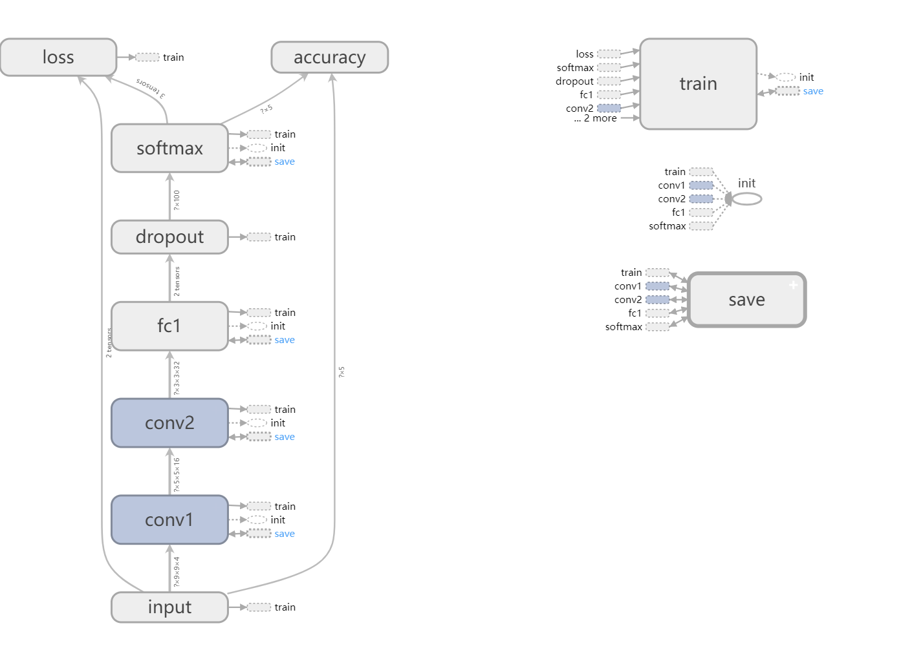

**Fig. 2.** Architecture of the CNN (m=9)

Fig. 2 illustrates the overall architecture of CNN (m = 9) system. In this neural network system, the number of convolutional layer (included convolutional operation and pooling) was chosen as two. The filters size was set to 3×3 with stride of 1 for obtain more spatial information between pixels and max-pooling (pooling unit was 2×2 with stride of 2) was used immediately after convolutional operation. After convolutional layer, fully-connected layer contained 1000 neurons was applied for increasing network complexity and robustness. Softmax layer was final layer and the number of neurons depended on the amount of classes. Activation function was important in neural network, as development of neural network, different activation function were found and used. The rectified linear units function was applied on outputs of convolutional layer and fully-connected layer in this paper. We chose the cross entropy function instead of the quadratic cost function for machine learning and the optimizer was the ADAM optimizer with learning rate of 0.0001. To implement this CNN, we have used Google’s tensorflow (an open source software library for machine intelligence) and Python library like geospatial data abstraction library (GDAL) and Numpy were used for reading and writing raster data. Fig. 3 shows the architecture of MLP. From top to bottom, the input layer (neurons in green) was set as four aforementioned, there are two hidden layers (neurons in blue) with 100 neurons in each layer and the output layer (neurons in orange) was set as five. The activation function and the cost function were same as the CNN and the optimizer is ADAM optimizer with learning rate 0.001.

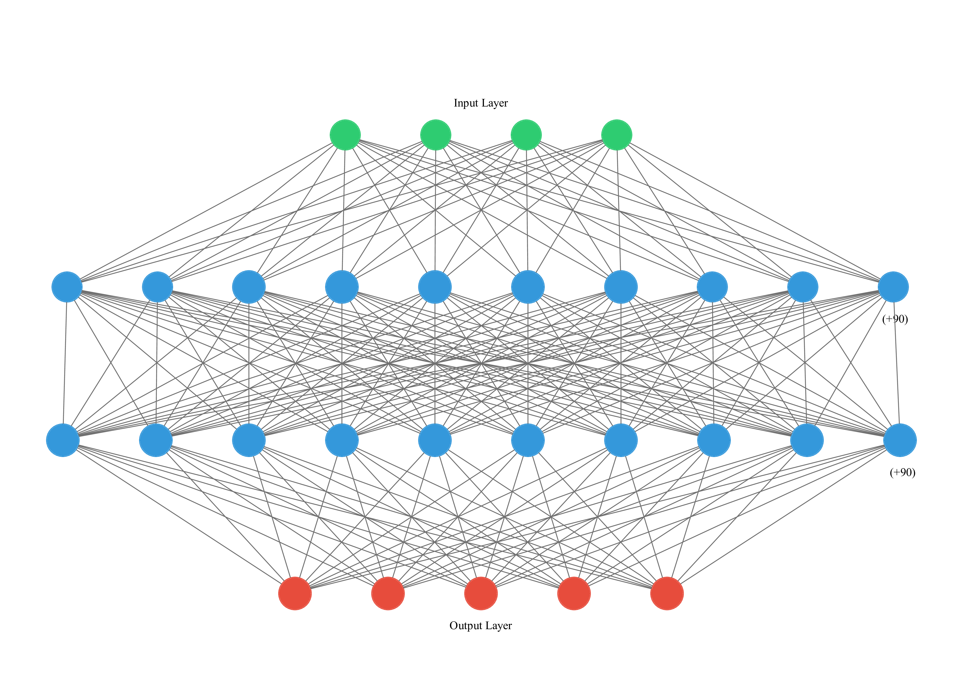

**Fig. 3.** Architecture of the MLP

## 4.3 Model training and evaluation

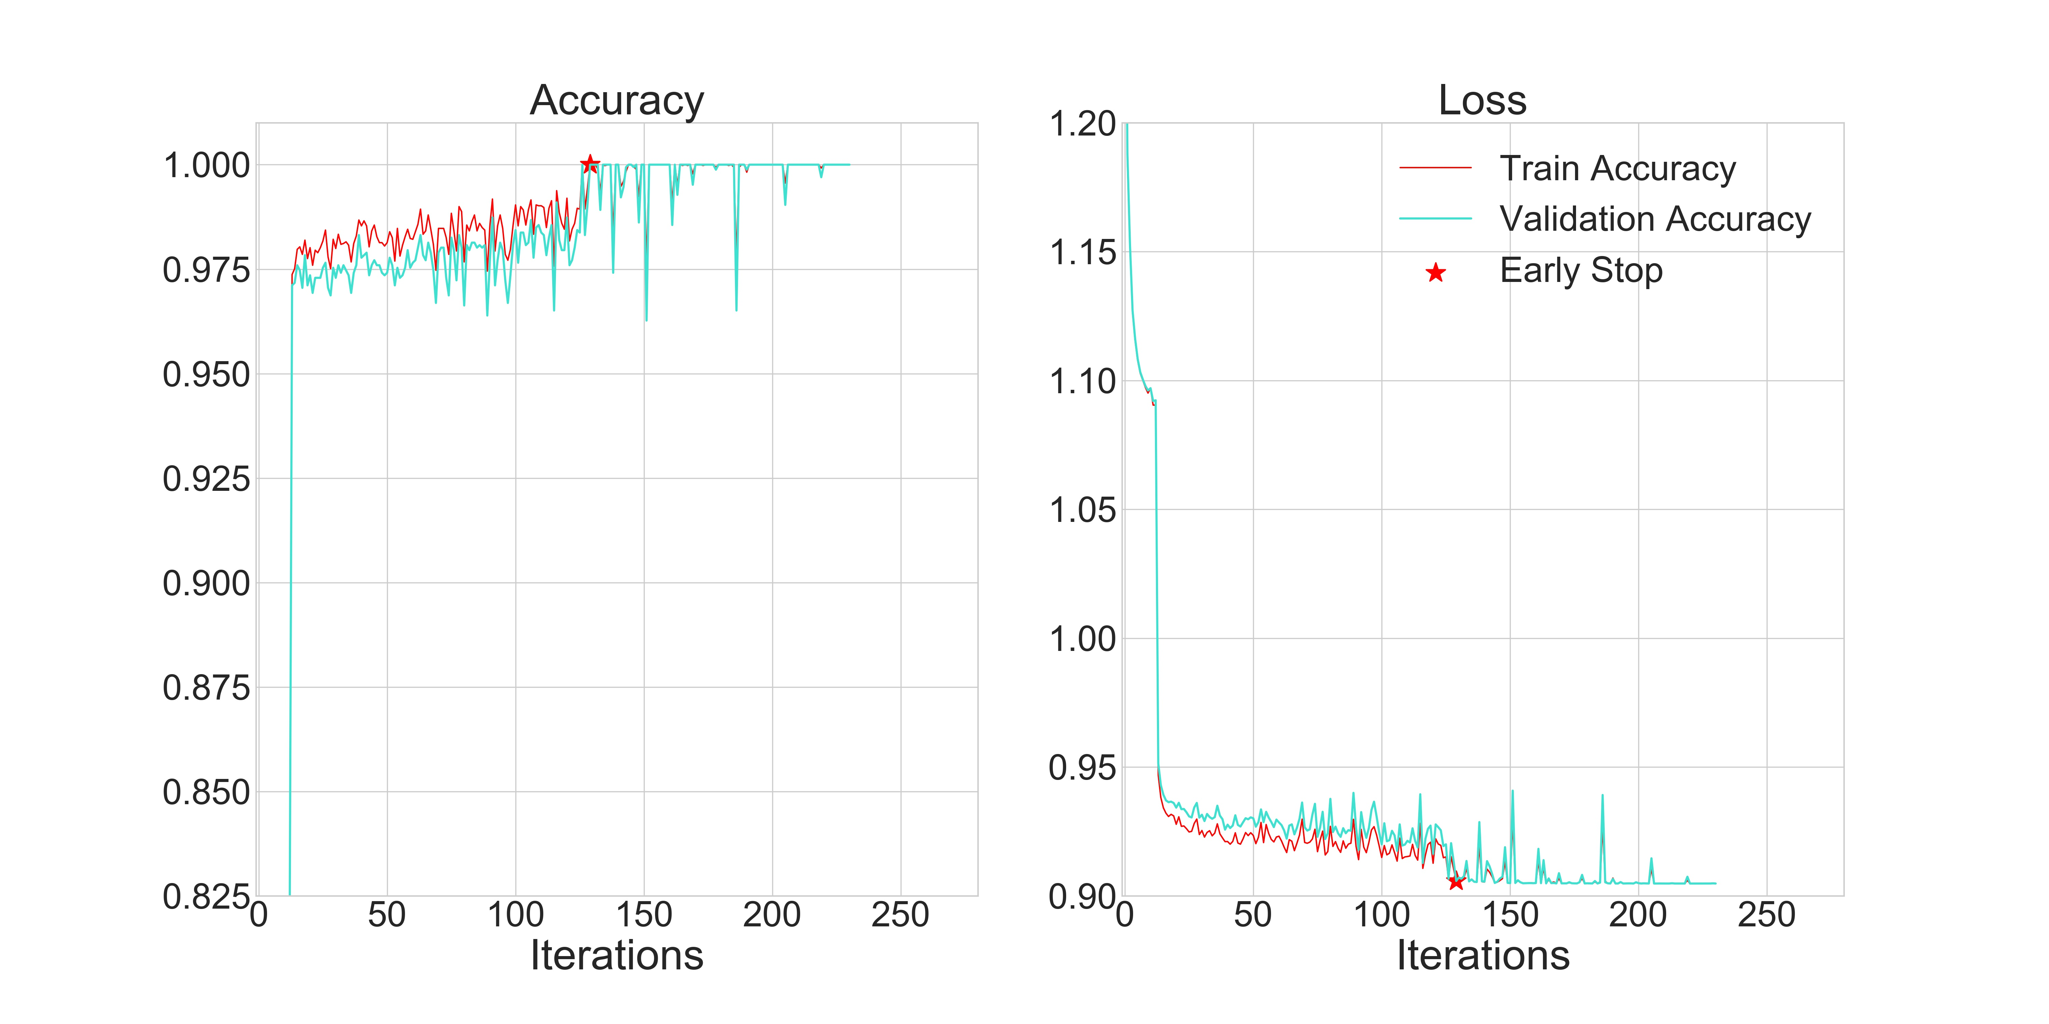

**Fig. 4.** Accuracy (left) and loss (right) of the CNN (m=9) in stage of training

Overfitting is a major problem in neural networks. This is especially true in modern networks, which often have very large numbers of weights and biases. To train effectively, we need detecting when overfitting is going on, so we stop and avoid overtraining. In this paper, we apply early stopping and dropout to avoid overfitting in neural networks. Once the classification accuracy on the validation data has saturated, we stop training. We recorded the training accuracy and validation accuracy with tensorboard (a module in tensorflow for visualizing learning) for judging whether saturated or not. When validation accuracy stops getting improvement in next 100 iterations and loss value of validation data do not decline anymore, we stop training. We start by randomly and temporarily deleting 50% neurons in the fully-connected layer in CNN, while leaving the remaining layers untouched. After doing this, we train the model like with different stricture of networks in every iterations and so we could get pretty result of training. There are other many measures of avoid overfitting, trying to solve model overfitting is necessary and important in training neural networks. Fig. 4 shows the accuracy, early stop point and loss value of CNN (m=9), as we can see from the graph, the loss value stop declining and the accuracy stop rising at 130th iteration, so we stop and save the weights and biases for the next classification.

**Table 2** Error matrix using the MLP

|  |  |  |  |  |  |
| --- | --- | --- | --- | --- | --- |
| class | Ground Truths (pixels) | | | | |
| Shrub | Masson's pine | Other broadleaf | Bare soil | Chinese fir |
| Shrub | **515** | 0 | 340 | 0 | 0 |
| Masson's pine | 0 | **1200** | 0 | 0 | 130 |
| Other broadleaf | 169 | 0 | **844** | 0 | 20 |
| Bare soil | 0 | 0 | 0 | **342** | 2 |
| Chinese fir | 6 | 121 | 6 | 5 | **1252** |
| Producer's accuracy (%) | 74.64 | 90.84 | 70.92 | 98.56 | 89.17 |
| User's accuracy (%) | 60.23 | 90.23 | 81.70 | 99.42 | 90.07 |

**Table 3** Error matrix using the CNN (m=5)

|  |  |  |  |  |  |
| --- | --- | --- | --- | --- | --- |
| class | Ground Truths (pixels) | | | | |
| Shrub | Masson's pine | Other broadleaf | Bare soil | Chinese fir |
| Shrub | **620** | 0 | 300 | 0 | 0 |
| Masson's pine | 0 | **1190** | 0 | 0 | 53 |
| Other broadleaf | 69 | 0 | **873** | 0 | 1 |
| Bare soil | 0 | 0 | 0 | **337** | 0 |
| Chinese fir | 4 | 131 | 17 | 10 | **1350** |
| Producer's accuracy (%) | 89.71 | 90.83 | 73.36 | 97.12 | 96.15 |
| User's accuracy (%) | 67.36 | 95.74 | 92.77 | 100 | 89.29 |

**Table 4** Error matrix using the CNN (m=7)

|  |  |  |  |  |  |
| --- | --- | --- | --- | --- | --- |
| class | Ground Truths (pixels) | | | | |
| Shrub | Masson's pine | Other broadleaf | Bare soil | Chinese fir |
| Shrub | **620** | 0 | 126 | 0 | 0 |
| Masson's pine | 0 | **1263** | 0 | 0 | 9 |
| Other broadleaf | 69 | 0 | **1064** | 0 | 1 |
| Bare soil | 0 | 0 | 0 | **325** | **0** |
| Chinese fir | 1 | 58 | 0 | 22 | **1647** |
| Producer's accuracy (%) | 89.86 | 95.61 | 89.41 | 93.66 | 96.65 |
| User's accuracy (%) | 83.11 | 97.45 | 92.76 | 100 | 94.37 |

**Table 5** Error matrix using the CNN (m=9)

|  |  |  |  |  |  |
| --- | --- | --- | --- | --- | --- |
| class | Ground Truths (pixels) | | | | |
| Shrub | Masson's pine | Other broadleaf | Bare soil | Chinese fir |
| Shrub | **605** | 0 | 59 | 0 | 0 |
| Masson's pine | 0 | **1288** | 0 | 0 | 30 |
| Other broadleaf | 78 | 11 | **1095** | 0 | 19 |
| Bare soil | 0 | 0 | 0 | **342** | 0 |
| Chinese fir | 7 | 13 | 36 | 5 | **1355** |
| Producer's accuracy (%) | 87.68 | 98.17 | 92.02 | 98.56 | 96.51 |
| User's accuracy (%) | 91.11 | 97.72 | 91.02 | 100 | 95.69 |

**Table 6** Error matrix using the CNN (m=11)

|  |  |  |  |  |  |
| --- | --- | --- | --- | --- | --- |
| class | Ground Truths (pixels) | | | | |
| Shrub | Masson's pine | Other broadleaf | Bare soil | Chinese fir |
| Shrub | **531** | 0 | 1 | 0 | 0 |
| Masson's pine | 0 | **1262** | 0 | 0 | 52 |
| Other broadleaf | 120 | 4 | **1137** | 0 | 24 |
| Bare soil | 0 | 0 | 0 | **293** | 0 |
| Chinese fir | 39 | 37 | 52 | 54 | **1328** |
| Producer's accuracy (%) | 76.96 | 96.85 | 95.55 | 84.44 | 94.59 |
| User's accuracy (%) | 99.81 | 96.04 | 88.48 | 100 | 87.95 |

**Table 7** Classification accuracy comparison amongst MLP, CNN (m=5), CNN (m=7), CNN (m=9) and CNN (m=11) for study area using per-class F score, overall accuracy and kappa coefficient. The bold font highlights the greatest classification accuracy per row.

|  |  |  |  |  |  |
| --- | --- | --- | --- | --- | --- |
| class | Classifier | | | | |
| MLP | CNN (m=5) | CNN (m=7) | CNN (m=9) | CNN (m=11) |
| Shrub | 0.6667 | 0.7694 | 0.8635 | **0.8936** | 0.8691 |
| Masson's pine | 0.9053 | 0.9282 | 0.9652 | **0.9794** | 0.9644 |
| Other broadleaf | 0.7593 | 0.8193 | 0.9106 | 0.9152 | **0.9188** |
| Bare soil | 0.9899 | 0.9854 | 0.9673 | **0.9927** | 0.9156 |
| Chinese fir | 0.8962 | 0.9259 | 0.9550 | **0.9610** | 0.9115 |
| Overall accuracy (%) | 83.87 | 88.23 | 93.48 | **94.78** | 92.24 |
| Kappa coefficient | 0.7904 | 0.8471 | 0.9149 | **0.9318** | 0.8979 |



**Fig.5.** Two image subsets (A and B) in study area with classification results. Columns from left to right represent the original images, the MLP classification and CNN (m=5, 7, 9 and 11) classification correspondingly.

# 5 EXPERIENTAL RESULTS

We have done accuracy assessment using error matrix which is generated from test samples, including the producer’s accuracy (hereafter, PA), user’s accuracy (hereafter, UA), overall accuracy (hereafter, OA), kappa coefficient (hereafter, kappa) and F score (hereafter, F). Table 2 to 6 lists error matrix of five systems respectively and Table 7 gives comparison amongst five systems using per-class F, OA and kappa.

From the Table 7, it can be seen that CNN (m=9) reports the best classification OA and kappa with up to 94.78% and 0.9318, higher than that of the MLP (83.87% and 0.7904, respectively), CNN (m=5) (88.23% and 0.9471, respectively) and CNN (m=7) (93.48% and 0.9149, respectively) as well as CNN (m=11) (92.24% and 0.8979, respectively). And their classification accuracy is ordered as: MLP < CNN (m=5) < CNN (m=11) < CNN (m=7) < CNN (m=9).

Table 7 also shows that there are significant improvements not only in OA and kappa but also in all the individual categories by the proposed CNN (m=9) system. In order to compare per-class classification accuracy amongst five systems, we introduced F (combined PA and UA) to evaluate performance of single class classification accuracy in different systems. As illustrated by the table, CNN (m=9) outperforms MLP and CNN (m=5) for all classes in terms of classification accuracy. The largest increase is up to 0.2269 for the class shrub in MLP and 0.1242 for the class shrub in CNN (m=5). When compared with the CNN (m=11), most classes expect for the class other broadleaf are classified with higher accuracy by CNN (m=9). And for the class of other broadleaf, the accuracy of the CNN (m=11) is slightly (only 0.0036 improvements) larger than that of the CNN (m=9), so they can be regarded as similar to each other. When compared with CNN (m=7), although we found that the F of per-class is close between each other, per-class accuracy gets obvious micro-improvements from CNN (m=7) to CNN (m=9). With respect to the results of MLP and CNN (i.e. m=5, m=7, m=11), it can be seen from the Table 7 that most classes expect for bare soil of CNN are classified with higher accuracy than MLP. Here, for the class bare soil, the accuracy of MLP is larger than that of the CNN, especially, higher 0.0743 than CNN (m=11).

From Fig. 5, it can be seen that the results of the MLP consist of undesirable noise, such as a severe salt-and-pepper effect, the class Chinese fir was misclassified as the class Masson’s pine in Fig. 5(A), and the class other broadleaf was misclassified as the class shrub in Fig. 5(B). However, the MLP has advantages in identifying the class bare soil with spectrally distinctive feature. In contrast to MLP, the classification results of CNN exhibits smoothed visual effects with least speckle noise as shown by Fig. 5. With respect to classification results of CNN (m=5) and CNN (m=7), the noise decreased, but the effect of salt-and-pepper still exits as shown by Fig. 5(A). As the image patches size increases (from 5 to 11), CNN delivers some uncertainties in partitioning object boundaries and some small or linear features are merged into a larger object or discarded by over-smoothness. As we can see from the result of CNN (m=11), the forest belt consist of other broadleaf was cut off and merged into the class Chinese fir (Fig. 5(A)) and some small distributions of Chinese fir were merged into the class other broadleaf (Fig. 5(B)). With respect to the results of the CNN (m=9), the issues of salt-and-pepper and boundaries are resolved with a pretty classification accuracy. Thus, the forest belt and small distribution of Chinese Fir were classified accurately as shown by Fig. 5(A) and Fig. 5(B).

# 6 DISCUSSION AND CONCLUSION

MLP, a traditional neural network, relies on the single pixel spectral information without exploiting the abundant spatial information in the high resolution remote sensing images. Due to this limitation, the MLP got undesirable performance, the OA (83.97%) and kappa (0.7904) is much lower than the proposed system CNN (m=9) (94.78% and 0.9318, respectively). For the class Chinese fir and the class other broadleaf, the MLP could identified correctly, however, the severe salt-and-pepper effects still exits. This reason results in lower accuracy of Chinese fir and other broadleaf (0.8962 and 7593, respectively) than the proposed system CNN (m=9) (0.9610 and 0.9152, respectively).

CNN, a popular deep learning network, could extract high-level spatial features from high resolution remote sensing images. Convolutional and pooling operation in CNN could reduce parameter dimensions, thus, avoiding “the curse of dimensionality”. Thanks to these superior characteristic, the CNN (i.e. m=5, 7, 9 and 11) outperforms the MLP in terms of classification accuracy. However, everything has two sides, CNN is also not an exception. As the image patches size increases, the effect of salt-and-pepper fade away gradually, whereas the issue of boundary uncertainties appear in CNN. Some small and linear features are erased or merged into large object as shown by Fig. 5. It is worth noting that the image patches size plays a key role in aforementioned issue. From the classification accuracy assessment, it shows that the CNN (m=9) achieves higher accuracy than other CNN. And when we apply the CNN for visual assessment, the proposed system (CNN (m=9)) alleviate the effect of salt-and-pepper and boundary uncertainties obviously.

In this paper, we have proposed a CNN system tailored for GF-2 remote sensing imagery trees species classification. The proposed CNN system obtains abundant spatial and spectral information of imagery for classification by using image patches size of 9. The proposed system is compared to the MLP and other CNN based different image patches size (i.e. m=5, 7 and 11), the classification results shows that the proposed system, CNN (m=9), achieves significant improvements in both the overall and categorical classification accuracies.

There are several changes that could lead to further improvements. The architecture of the CNN and choice of hyper-parameters are worth investigating further for increasing network robustness. The classification accuracy could improve further by utilizing more auxiliary data sources (e.g. canopy height model). Moreover, combining different image patches size or integrating different classifiers (e.g. support vector machine and random forest) may get unexpected classification results.

**Acknowledgements:** the authors would like to thank the anonymous reviewers whose comments and suggestions have improved the presentation of this paper significantly.

# REFERENCES

Alonzo, M., B. Bookhagen and D. A. Roberts (2014). "Urban tree species mapping using hyperspectral and lidar data fusion." Remote Sensing of Environment **148**: 70-83.

Axelsson, A., E. Lindberg and H. Olsson (2018). "Exploring Multispectral ALS Data for Tree Species Classification." Remote Sensing **10**(2).

Basaeed, E., H. Bhaskar and M. Al-Mualla (2016). "Supervised remote sensing image segmentation using boosted convolutional neural networks." Knowledge-Based Systems **99**: 19-27.

Chambers, D., C. Perie, N. Casajus and S. de Blois (2013). "Challenges in modelling the abundance of 105 tree species in eastern North America using climate, edaphic, and topographic variables." Forest Ecology and Management **291**: 20-29.

Dalponte, M., L. Bruzzone and D. Gianelle (2012). "Tree species classification in the Southern Alps based on the fusion of very high geometrical resolution multispectral/hyperspectral images and LiDAR data." Remote Sensing of Environment **123**: 258-270.

Fassnacht, F. E., H. Latifi, K. Sterenczak, A. Modzelewska, M. Lefsky, L. T. Waser, C. Straub and A. Ghosh (2016). "Review of studies on tree species classification from remotely sensed data." Remote Sensing of Environment **186**: 64-87.

Hu, F., G. S. Xia, J. W. Hu and L. P. Zhang (2015). "Transferring Deep Convolutional Neural Networks for the Scene Classification of High-Resolution Remote Sensing Imagery." Remote Sensing **7**(11): 14680-14707.

Kumar, U., N. Kerle, M. Punia and T. V. Ramachandra (2010). "Mining Land Cover Information Using Multilayer Perceptron and Decision Tree from MODIS Data." Journal of the Indian Society of Remote Sensing **38**(4): 592-603.

Langkvist, M., A. Kiselev, M. Alirezaie and A. Loutfi (2016). "Classification and Segmentation of Satellite Orthoimagery Using Convolutional Neural Networks." Remote Sensing **8**(4).

Marir, B., M. Kalla, F. Douak and A. Daamouche (2018). "A Modular Support Vector Machine for Active Learning of Urban Remote Sensing Images Classification in Algeria." Journal of the Indian Society of Remote Sensing **46**(4): 515-529.

Marmanis, D., K. Schindler, J. D. Wegner, S. Galliani, M. Datcu and U. Stilla (2018). "Classification with an edge: Improving semantic with boundary detection." Isprs Journal of Photogrammetry and Remote Sensing **135**: 158-172.

Mas, J. F. and J. J. Flores (2008). "The application of artificial neural networks to the analysis of remotely sensed data." International Journal of Remote Sensing **29**(3): 617-663.

Mishra, V. N. and P. K. Rai (2016). "A remote sensing aided multi-layer perceptron-Markov chain analysis for land use and land cover change prediction in Patna district (Bihar), India." Arabian Journal of Geosciences **9**(4).

Mountrakis, G., J. Im and C. Ogole (2011). "Support vector machines in remote sensing: A review." Isprs Journal of Photogrammetry and Remote Sensing **66**(3): 247-259.

Nogueira, K., O. A. B. Penatti and J. A. dos Santos (2017). "Towards better exploiting convolutional neural networks for remote sensing scene classification." Pattern Recognition **61**: 539-556.

Othmana, E., Y. Bazi, N. Alajlan, H. Alhichri and F. Melgani (2016). "Using convolutional features and a sparse autoencoder for land-use scene classification." International Journal of Remote Sensing **37**(10): 2149-2167.

Pal, M. and P. M. Mather (2005). "Support vector machines for classification in remote sensing." International Journal of Remote Sensing **26**(5): 1007-1011.

Pham, T. D., D. T. Bui, K. Yoshino and N. N. Le (2018). "Optimized rule-based logistic model tree algorithm for mapping mangrove species using ALOS PALSAR imagery and GIS in the tropical region." Environmental Earth Sciences **77**(5).

Phiri, D. and J. Morgenroth (2017). "Developments in Landsat Land Cover Classification Methods: A Review." Remote Sensing **9**(9).

Ren, S. Q., K. M. He, R. Girshick and J. Sun (2017). "Faster R-CNN: Towards Real-Time Object Detection with Region Proposal Networks." Ieee Transactions on Pattern Analysis and Machine Intelligence **39**(6): 1137-1149.

Ren, Y., C. R. Zhu and S. P. Xiao (2018). "Small Object Detection in Optical Remote Sensing Images via Modified Faster R-CNN." Applied Sciences-Basel **8**(5).

Rodriguez-Galiano, V. F., M. Chica-Olmo, F. Abarca-Hernandez, P. M. Atkinson and C. Jeganathan (2012). "Random Forest classification of Mediterranean land cover using multi-seasonal imagery and multi-seasonal texture." Remote Sensing of Environment **121**: 93-107.

Satir, O., S. Berberoglu and C. Donmez (2016). "Mapping regional forest fire probability using artificial neural network model in a Mediterranean forest ecosystem." Geomatics Natural Hazards & Risk **7**(5): 1645-1658.

Sharma, A., X. W. Liu, X. J. Yang and D. Shi (2017). "A patch-based convolutional neural network for remote sensing image classification." Neural Networks **95**: 19-28.

Shi, Y. F., T. J. Wang, A. K. Skidmore and M. Heurich (2018). "Important LiDAR metrics for discriminating forest tree species in Central Europe." Isprs Journal of Photogrammetry and Remote Sensing **137**: 163-174.

Xu, X. D., W. Li, Q. Ran, Q. Du, L. R. Gao and B. Zhang (2018). "Multisource Remote Sensing Data Classification Based on Convolutional Neural Network." Ieee Transactions on Geoscience and Remote Sensing **56**(2): 937-949.

Yang, S., Q. Feng, T. Liang, B. Liu, W. Zhang and H. Xie (2018). "Modeling grassland above-ground biomass based on artificial neural network and remote sensing in the Three-River Headwaters Region." Remote Sensing of Environment **204**: 448-455.

Yue, J., S. J. Mao and M. Li (2016). "A deep learning framework for hyperspectral image classification using spatial pyramid pooling." Remote Sensing Letters **7**(9): 875-884.

Zhang, C., X. Pan, H. Li, A. Gardiner, I. Sargent, J. Hare and P. M. Atkinson (2018). "A hybrid MLP-CNN classifier for very fine resolution remotely sensed image classification." ISPRS Journal of Photogrammetry and Remote Sensing **140**: 133-144.

Zhao, Y. J., Y. Zeng, Z. J. Zheng, W. X. Dong, D. Zhao, B. F. Wu and Q. J. Zhao (2018). "Forest species diversity mapping using airborne LiDAR and hyperspectral data in a subtropical forest in China." Remote Sensing of Environment **213**: 104-114.